I
n this session we will look at what is service task and how it functions ?.

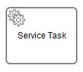

Service Tasks are used to perform some form of "technical" task. Whenever you want to perform calculations, trigger some action within your application’s back end or integrate with another system, it often involves Service Tasks.

In many cases you want to store the result of an operation carried out by a Service Task in a variable. The resulting variable name is specified in the Result variable attribute.

Camunda Service Task

There are four ways of declaring how to invoke Java logic:

- Specifying a class that implements a JavaDelegate or ActivityBehavior
- Evaluating an expression that resolves to a delegation object
- Invoking a method expression
- Evaluating a value expression

- We will use process application as we had created on day 1 to demonstrate service task as a class that implements a JavaDelegate.
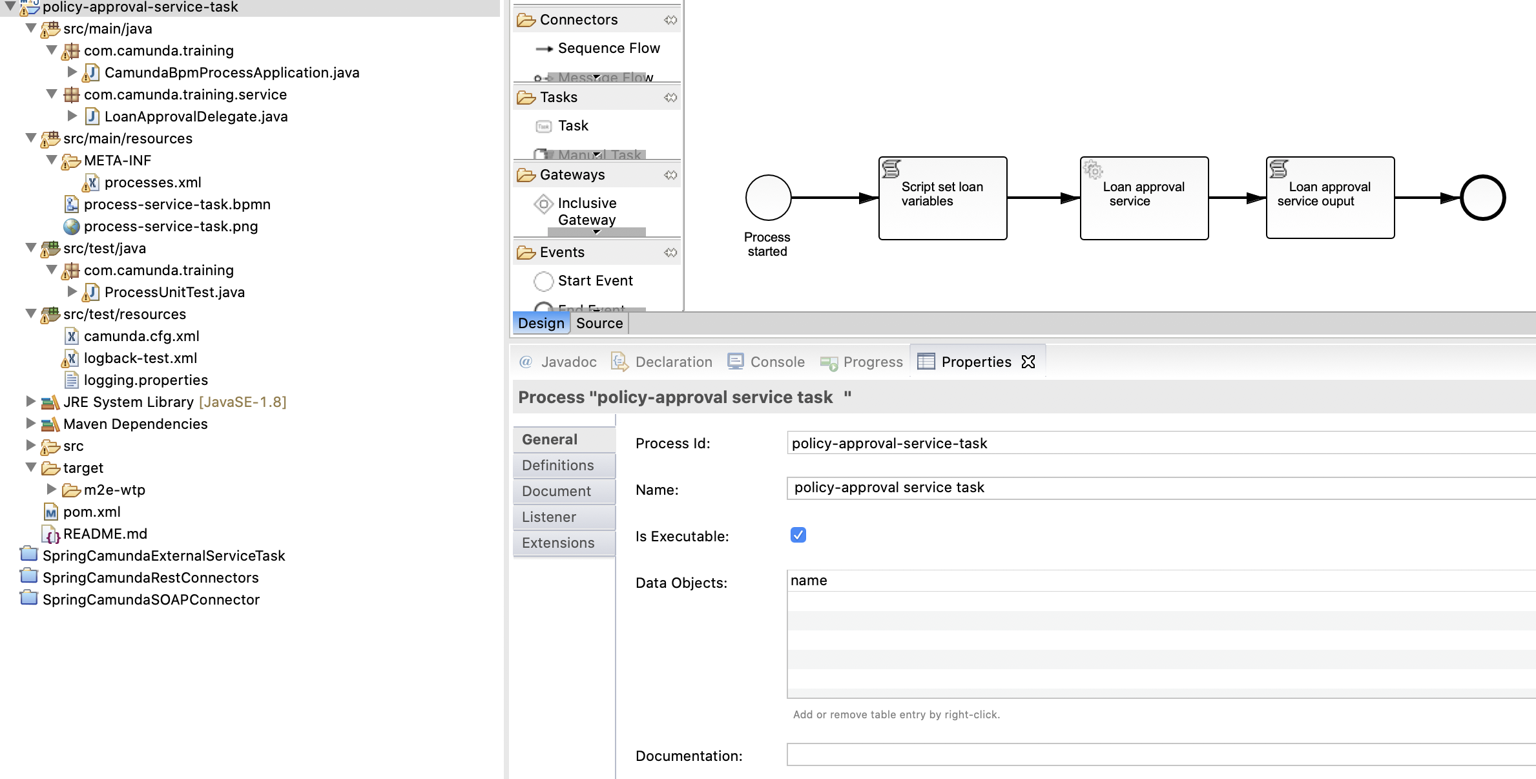

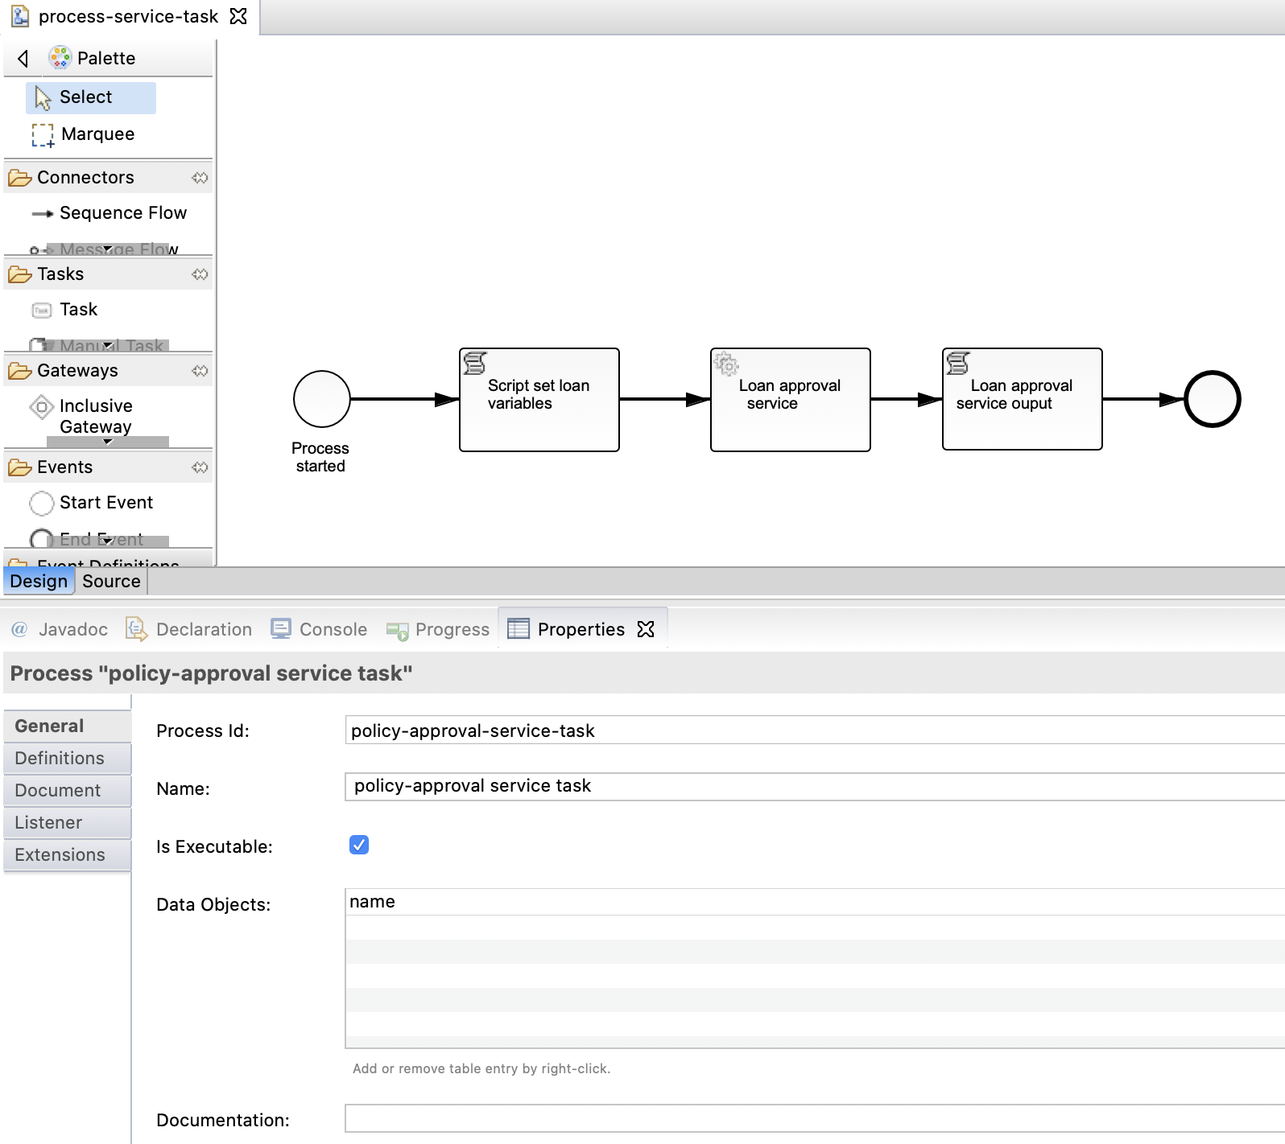
2. Process: policy-approval service task
Process Id: policy-approval-service-task
Name: policy-approval service task

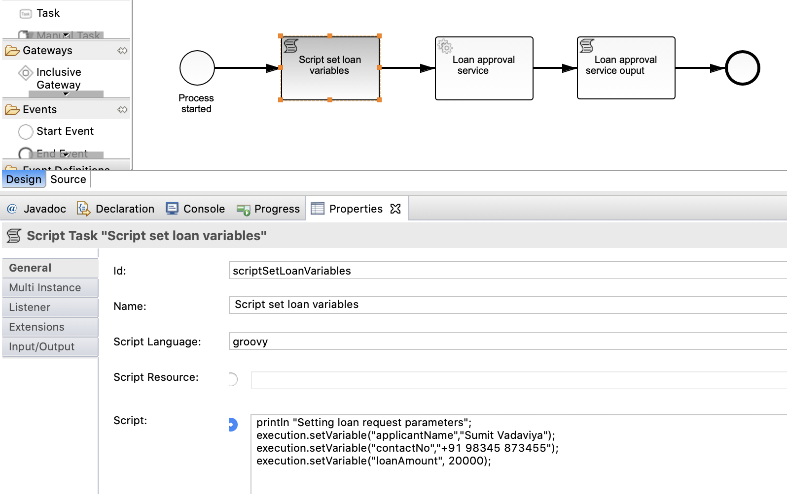
3. Script task: scriptSetLoanVariables

Id: scriptSetLoanVariables
Name: Script set loan variables
Script language: groovy
Script:
println "Setting loan request parameters";
execution.setVariable("applicantName","Sumit Vadaviya");
execution.setVariable("contactNo","+91 98345 873455");
execution.setVariable("loanAmount", 20000);
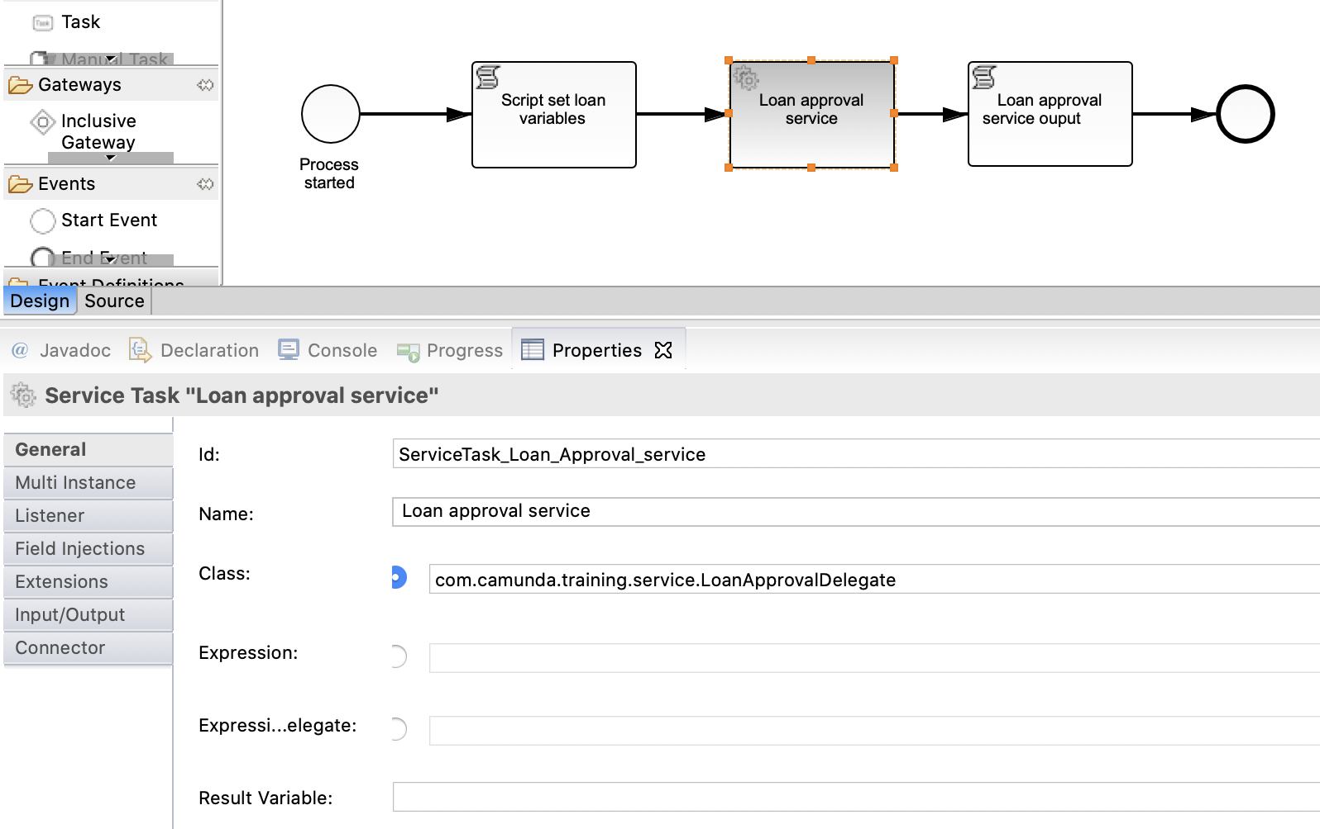
4. Service task: scriptSetLoanVariables

Id: ServiceTask_Loan_Approval_service
Name: Loan approval service
Class: com.camunda.training.service.LoanApprovalDelegate

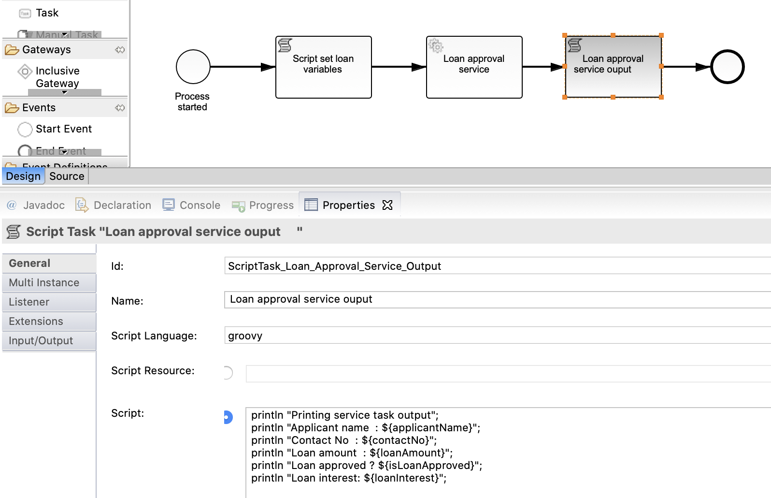
5. Script task: ScriptTask_Loan_Approval_Service_Output

Id: ScriptTask_Loan_Approval_Service_Output
Name: Loan approval service ouput
Script language: groovy
Script:
println "Printing service task output";
println "Applicant name : ${applicantName}";
println "Contact No : ${contactNo}";
println "Loan amount : ${loanAmount}";
println "Loan approved ? ${isLoanApproved}";
println "Loan interest: ${loanInterest}”;

Service task class implementation

package com.camunda.training.service;

import java.util.logging.Logger;
import org.camunda.bpm.engine.delegate.DelegateExecution;
import org.camunda.bpm.engine.delegate.JavaDelegate;

/**
* This is an easy adapter implementation illustrating how a Java Delegate can
* be used from within a BPMN 2.0 Service Task.
*/
public class LoanApprovalDelegate implements JavaDelegate {

private final Logger LOGGER = Logger.getLogger(LoanApprovalDelegate.class.getName());

public void execute(DelegateExecution execution) throws Exception {

LOGGER.info("\n\n ... LoanApprovalDelegate invoked by " + "processDefinitionId="
+ execution.getProcessDefinitionId() + ", activtyId=" + execution.getCurrentActivityId()
+ ", activtyName='" + execution.getCurrentActivityName() + "'" + ", processInstanceId="
+ execution.getProcessInstanceId() + ", businessKey=" + execution.getProcessBusinessKey()
+ ", executionId=" + execution.getId() + " \n\n");

String applicantName = (String) execution.getVariable("applicantName");
String contactNo = (String) execution.getVariable("contactNo");
Integer loanAmount = (Integer) execution.getVariable("loanAmount");

LOGGER.info("applicantName : " + applicantName);
LOGGER.info("contactNo : " + contactNo);
LOGGER.info("loanAmount : " + loanAmount);

if (loanAmount < 10000) {
execution.setVariable("isLoanApproved", false);
} else if (loanAmount >= 10000 && loanAmount < 50000) {
execution.setVariable("loanInterest", 9.0);
execution.setVariable("isLoanApproved", true);
} else if (loanAmount >= 50000 && loanAmount < 100000) {
execution.setVariable("loanInterest", 8.0);
execution.setVariable("isLoanApproved", true);
}

LOGGER.info("loanInterest : " + execution.getVariable("loanInterest"));
LOGGER.info("isLoanApproved : " + execution.getVariable("isLoanApproved"));

}
}

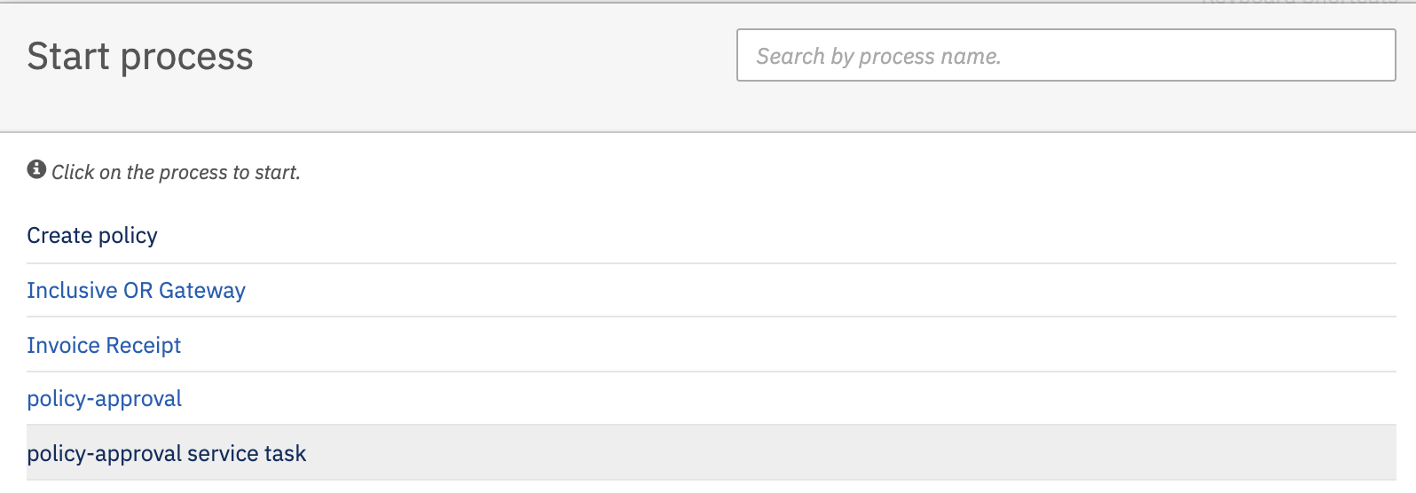
Build the application and deploy

Hit the Start button to start the process.

Observe tomcat console output

31-Aug-2020 09:00:50.965 INFO [Catalina-utility-1] org.apache.catalina.startup.HostConfig.deployWAR Deployment of web application archive [/Volumes/Trainings/Camunda/Softwares/camunda-bpm-tomcat-7.13.0/server/apache-tomcat-9.0.33/webapps/policy-approval-service-task.war] has finished in [3,327] ms
Setting loan request parameters
31-Aug-2020 09:02:09.953 INFO [http-nio-8081-exec-25] com.camunda.training.service.LoanApprovalDelegate.execute

... LoanApprovalDelegate invoked by processDefinitionId=24496e38-eba3-11ea-ba24-026b97bcf0fc, activtyId=ServiceTask_Loan_Approval_service, activtyName='Loan approval service', processInstanceId=535a3a69-eba3-11ea-ba24-026b97bcf0fc, businessKey=null, executionId=535a3a69-eba3-11ea-ba24-026b97bcf0fc

31-Aug-2020 09:02:09.954 INFO [http-nio-8081-exec-25] com.camunda.training.service.LoanApprovalDelegate.execute applicantName : Sumit Vadaviya
31-Aug-2020 09:02:09.954 INFO [http-nio-8081-exec-25] com.camunda.training.service.LoanApprovalDelegate.execute contactNo : +91 98345 873455
31-Aug-2020 09:02:09.954 INFO [http-nio-8081-exec-25] com.camunda.training.service.LoanApprovalDelegate.execute loanAmount : 20000
31-Aug-2020 09:02:09.954 INFO [http-nio-8081-exec-25] com.camunda.training.service.LoanApprovalDelegate.execute loanInterest : 9.0
31-Aug-2020 09:02:09.954 INFO [http-nio-8081-exec-25] com.camunda.training.service.LoanApprovalDelegate.execute isLoanApproved : true
Printing service task output
Applicant name : Sumit Vadaviya
Contact No : +91 98345 873455
Loan amount : 20000
Loan approved ? true
Loan interest: 9.0

You can see script task Script set loan variables is executed by setting loan variables, after script task service task ServiceTask_Loan_Approval_service is invoked from process and it has perform business logic execution to decide loan interest rate and then again script task ScriptTask_Loan_Approval_Service_Output is executed to print the service task output.

Service task implementation through expression

It is also possible to use an expression that resolves to an object. This object must follow the same rules as objects that are created when the camunda:class attribute is used.

<serviceTask id="beanService"
name="My Bean Service Task"
camunda:delegateExpression="${myDelegateBean}" />

Service task implementation through expression which calls method

Or an expression which calls a method or resolves to a value.
<serviceTask id="expressionService"
name="My Expression Service Task"
camunda:expression="${myBean.doWork()}" />

We will demonstrate service task implementation through expression with camunda integration with Spring boot as it requires bean for service task implementation.

